
Press Release
Paris, September 18, 2014

Orange Business Services launches worldwide location services for Machine to Machine SIM cards
The new Machine to Machine (M2M) worldwide geolocation offering from Orange Business Services provides real-time location tracking of corporate assets and equipment anywhere in the world via cellular networks, regardless of the operator.

Enterprises can choose either the turnkey version accessible from the Orange Business Services M2M web portal (including its SIM card location mapped interface) or an API option to be further integrated in its IT environment.
The worldwide geolocation service can remotely query the SIM card in less than a minute and determine:
- the country where the equipment is located and the network/operator to which it is connected;
- the geographic location and position of the terminal (longitude/latitude);
- the hardware identity via the SIM card's IMEI (International Mobile Equipment Identity);
- the level of network signal.
To enable the geolocation of the communicating devices, the solution does not require any software development nor GPS hardware additions. Moreover, by operating in any area covered by a cellular network, the system provides location services both indoors and outdoors .
100% Orange – Innovation in international location GUI and services
Orange Labs experts have developed an M2M SIM card handling connection to any type of cellular network, combined with an innovative platform to query remote cards, collect geographic information and display their location on an actual map.

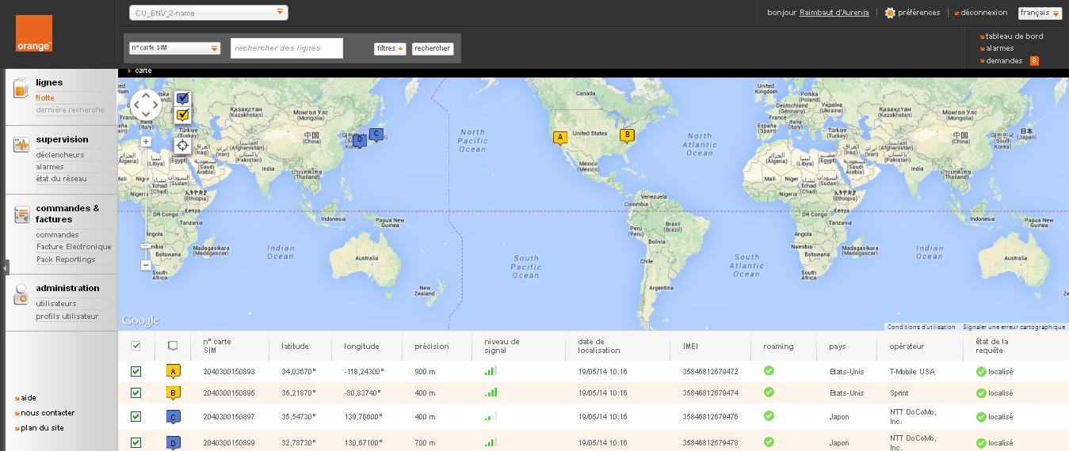

Real time feedback from field operations, remote equipment management, preventive maintenance, luggage monitoring, security of construction equipment, fleet management, precious-asset tracking... there are numerous uses for this service.

With new business processes and new service development, M2M technologies – and more widely the Internet of Things – offer new possibilities to companies and are at the core of their digital transformation. They are a key priority for Orange Business Services, which leverages its dual capabilities of both global operator and integrator to support companies from their connectivity needs to end-to-end solutions.

About Orange Business Services
Orange Business Services, the Orange branch dedicated to B2B services, is a leading global integrator of communications solutions for multinational corporations. With the world's largest, seamless network for voice and data, Orange Business Services reaches 220 countries and territories with local support in more than 160. Offering a comprehensive package of communication services covering cloud computing, enterprise mobility, M2M, security, unified communications, videoconferencing, and broadband, Orange Business Services delivers a best-in-class customer experience across a global landscape. Thousands of enterprise customers and 1.4 million mobile data users rely on an Orange Business Services international platform for communicating and conducting business. Orange Business Services was awarded four of the telecom industry’s highest accolades at the annual World Communication Awards 2013 – Best Global Operator, Best Cloud Service, Best Enterprise Service and Best Small Business Service. Orange Business Services is the only seven-time winner of Best Global Operator. Learn more at www.orange-business.com or follow us on LinkedIn, Twitter or Facebook.

Orange is one of the world’s leading telecommunications operators with annual sales of €41 billion in 2013 and has 161,000 employees worldwide at June 30, 2014. Orange is listed on the NYSE Euronext Paris (symbol ORA) and on the New York Stock Exchange (symbol ORAN).

Orange and any other Orange product or service names included in this material are trademarks of Orange Brand Services Limited.

Press Contacts:
Gwenaëlle Martin Delfosse, Orange Business Services, gwenaelle.martindelfosse@orange.com, +33 1 44 37 62 62
Elizabeth Mayeri, Orange Business Services, Elizabeth.mayeri@orange.com, 212.251.2086
Sylvie Duho, Orange, sylvie.duho@orange.com, 01 44 44 93 93

