Press Release

Paris, December 1, 2014

Orange Business Services and iDBUS Collaborate to Improve Wi-Fi Coverage on Long Distance Coaches

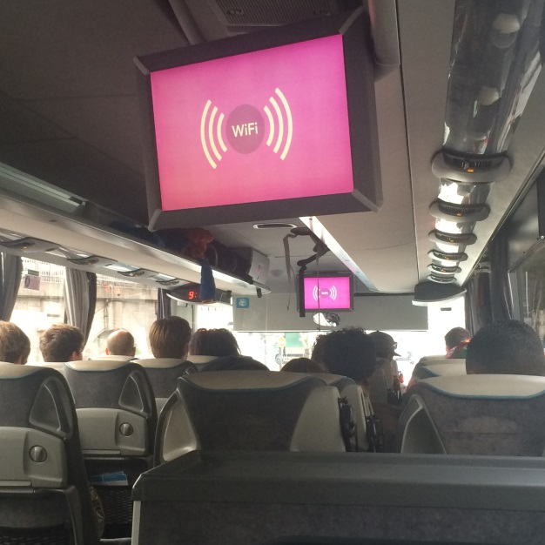

**iDBUS, the new SNCF long-distance coach service, offering European travelers unprecedented levels of comfort and service, has chosen Orange Business Services to provide advanced Wi-Fi services to its passengers via the Orange broadband mobile network. Featuring free Wi-Fi on board since 2012, all iDBUS vehicles are now equipped with Orange M2M SIM cards, improving passenger connectivity.**

Today, 50% of iDBUS customers regularly connect to the Internet during their trips. To continue to provide a superior quality of service with increasing network traffic, iDBUS chose to deploy a new on-board connection service.

"*Remaining connected while traveling has become a necessity, and Wi-Fi availability is among the top criteria for choosing our company. iDBUS was a pioneer in this field and played a major role in the deployment of pervasive on-board connectivity solutions,*" said Laurent Lenoir, Director of Information Systems at iDBUS.

“*For Orange, providing a positive customer experience is key. We are delighted to extend the quality of our mobile network to iDBUS and thus help offer value-added services for their passengers,*” said Valérie Cussac, Vice-President Mobile France & International, Orange.

In France, travelers leverage the Orange mobile network, voted number 1 for the 4th consecutive year by the ARCEP[1]/2. In other European countries, passengers can rely on Internet access through Orange roaming agreements with major European operators. iDBUS customers can take advantage of the free unlimited iDBUS – Orange Wi-Fi network access on their smartphones, tablets or laptops – in all of the countries through which they travel.

The new solution relies on embedded Orange M2M SIM cards. Each coach is also equipped with a router converting the cellular connections of SIM cards into a Wi-Fi network connection and is available to all passengers. Orange Business Services guarantees a superior quality of service and provides iDBUS with an administration platform that allows them to manage SIM card consumption and subscription status.

SNCF launched its iDBUS offer in 2012 as a seamless, cost-effective and comfortable transport alternative to travel across Europe. Available in France, the UK, Belgium, the Netherlands, Italy, Spain and in Germany, iDBUS currently reaches 19 European destinations. iDBUS has been offering free Wi-Fi services to its passengers across its fleet since launch.

ABOUT ORANGE BUSINESS SERVICES

Orange Business Services, the Orange branch dedicated to B2B services, is a leading global integrator of communication solutions for multinational corporations. With the world's largest, seamless network for voice and data, Orange Business Services covers 220 countries and territories with local support in 166. Offering a comprehensive package of communication services covering cloud computing, enterprise mobility, M2M, security, unified communications, videoconferencing, and broadband, Orange Business Services delivers a best-in-class customer experience across a global landscape. Thousands of enterprise customers and 1.69 million users of the Business Everywhere solution rely on an Orange Business Services international platform for communicating and conducting business. Orange Business Services is a five-time winner of Best Global Operator.

For more information: www.orange-business.com, http://www.orange-business.com/fr/videos, www.orange-business.com/fr/blogs, http://www.linkedin.com/company/orange-business-services or follow us on Twitter: @orangebusiness

Pour en savoir plus : [www.orange-business.com](http://www.orange-business.com/), <http://www.orange-business.com/fr/videos>, [www.orange-business.com/fr/blogs](http://www.orange-business.com/fr/blogs), <http://www.linkedin.com/company/orange-business-services> ou nous suivre sur Twitter : [@orangebusiness](https://twitter.com/orangebusiness)

Orange is one of the leading telecommunications operators in the world, with a turnover of € 41 billion in 2013 and 159,000 employees as of September 30, 2014 (98,800 in France). Orange is listed on NYSE Euronext Paris (symbol ORA ) and on the New York Stock Exchange (ORAN).

Orange and any other Orange product or service names included in this material are trademarks of Orange or Orange Brand Services Limited.

ABOUT iDBUS

In creating iDBUS, SNCF is reinventing coach travel in Europe. iDBUS is a new offer for travel by coach, with high levels of comfort and security, whilst being ecological and responding to the latest mobility needs of Europeans. iDBUS offers more comfort, attention and information before, during and after the journey, and has simple permanent and economical tariffs. It is an easy and convivial way to travel.

Travelers can reserve on the website www.idbus.com or by telephone (0844 369 0 379 - 5p/min. plus network extras, open Monday to Saturday from 7:30 am to 7 pm).

Follow iDBUS: facebook.com/iDBUS and twitter.com/iDBUS

ABOUT SNCF GROUP

Present in 120 countries, SNCF is a world leader in mobility and logistics. Its total workforce of 250,000 generated revenue of €33.8 billion in 2012, with over 1/5 of sales from markets outside France. A public sector group dedicated to public service, SNCF builds on its foundations in rail to offer a broad range of services, delivering seamless door-to-door mobility for transport and logistics operators, passengers and the regional and local governments that are its organizing authorities. SNCF Group targets cross-border and international markets, and has five divisions: SNCF Infra manages, operates, maintains and develops rail and related infrastructure; SNCF Proximités operates local, urban and regional passenger services; SNCF Voyages operates long-distance passenger services and distribution; SNCF Geodis provides freight and logistics services; and Gares & Connexions manages and develops train stations. www.sncf.com

PRESS CONTACT

**Orange Business Services**

Elizabeth Mayeri, [elizabeth.mayeri@orange.com](mailto:elizabeth.mayeri@orange.com), +1 212 251 2086

**iDBUS**

Adeline Prévost, [adeline.prevost@cohnwolfe.com](mailto:adeline.prevost@cohnwolfe.com), 01 49 70 43 03

Cyndie Medeiros, [cyndie.medeiros@cohnwolfe.com](mailto:cyndie.medeiros@cohnwolfe.com), 01 49 70 43 35

1. Regulatory Authority for Electronic and Postal Communications Services. The June 2014 report on "QoS of voice and data mobile network operators in mainland France" confirms that Orange offers the best 2G / 3G / H + mobile network in France.

   2 For the 4th time Orange was elected by ACERP number 1, being 1st or 1st equally on 246 out of 258 measured criteria